Business Report
BonanzA E-Commerce Application for Black Friday Sales

Date: April 18, 2025
BonanzA Product Development Office
Bangalore
Dear Emily Watson,
IT technical lead, UK
Introduction
We are proud to present this business report which gives a comprehensive study report on the development and deployment of BonanzA e-commerce application designed to handle the high traffic demands of Black Friday sales. The primary objective is to create a resilient, scalable, and seamless application on mobile and web app that meets the stringent requirements of both functional and non-functional aspects. This report is tailored and aims to provide a balanced mix of technical and business language, ensuring clarity and precision.
Business Context and Goals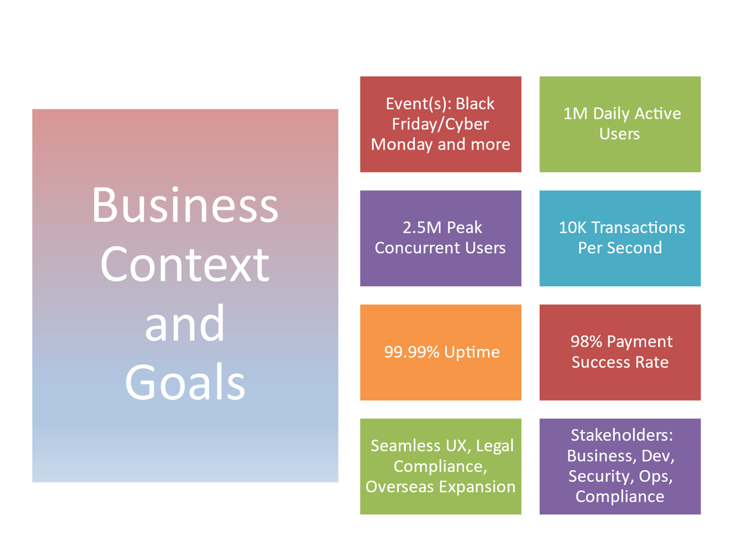
The e-commerce company aims to launch a new platform built on serverless, microservice based AWS Cloud platform with Elastic Load balancer, Elastic Cache, Data Caching at various levels along with high-speed data bus, state management and streaming services. Application leverage on time tested and highly scalable AWS Services and custom build modules which ensure highly secure, scalable and efficient application. BonanzA can support high-traffic events like Black Friday, cyber-Monday etc. Pay-as-you-go pricing effectively use the infrastructure and ensures the availability of highly scalable infrastructure on demand. This is the best option for applications which require to handle very high volumes for a very short time. The system is resilient, scalable, and provides seamless transactions. The key requirements are as follows:
- Users:
  - Expected Daily Active Users: 1 million
  - Peak Concurrent Users: 250,000
  - Transactions per Second (TPS): 10,000
  - Supported Platforms: Web, Mobile (iOS & Android)
- Functional Requirements:
  - Secure user authentication (SSO, MFA)
  - Product catalog, shopping cart, and checkout
  - Multiple payment gateway integrations with failover
  - Order tracking, notifications, and user reviews
  - Admin dashboard with analytics and role-based access
- Non-Functional Requirements:
  - 99.99% uptime, auto-scaling for peak loads
  - API response time < 200ms, payment success rate > 98%
  - PCI DSS, GDPR, and CCPA compliance
  - UK Specific Compliance:
  - UK General Data Protection Regulation (UK GDPR) and the Data Protection Act 2018
  - Privacy and Electronic Communications Regulations 2003 (PECR)
  - The Consumer Rights Act 2015
  - Consumer Contracts (Information, Cancellation and Additional Charges) Regulations 2013
  - Consumer Protection from Unfair Trading Regulations 2008
  - Payment Card Industry Data Security Standard (PCI DSS)
  - Electronic Commerce (EC Directive) Regulations 2002
  - Accessibility: Equality Act 2010

Systems and Subsystems
To deliver the required functionality, we propose server the
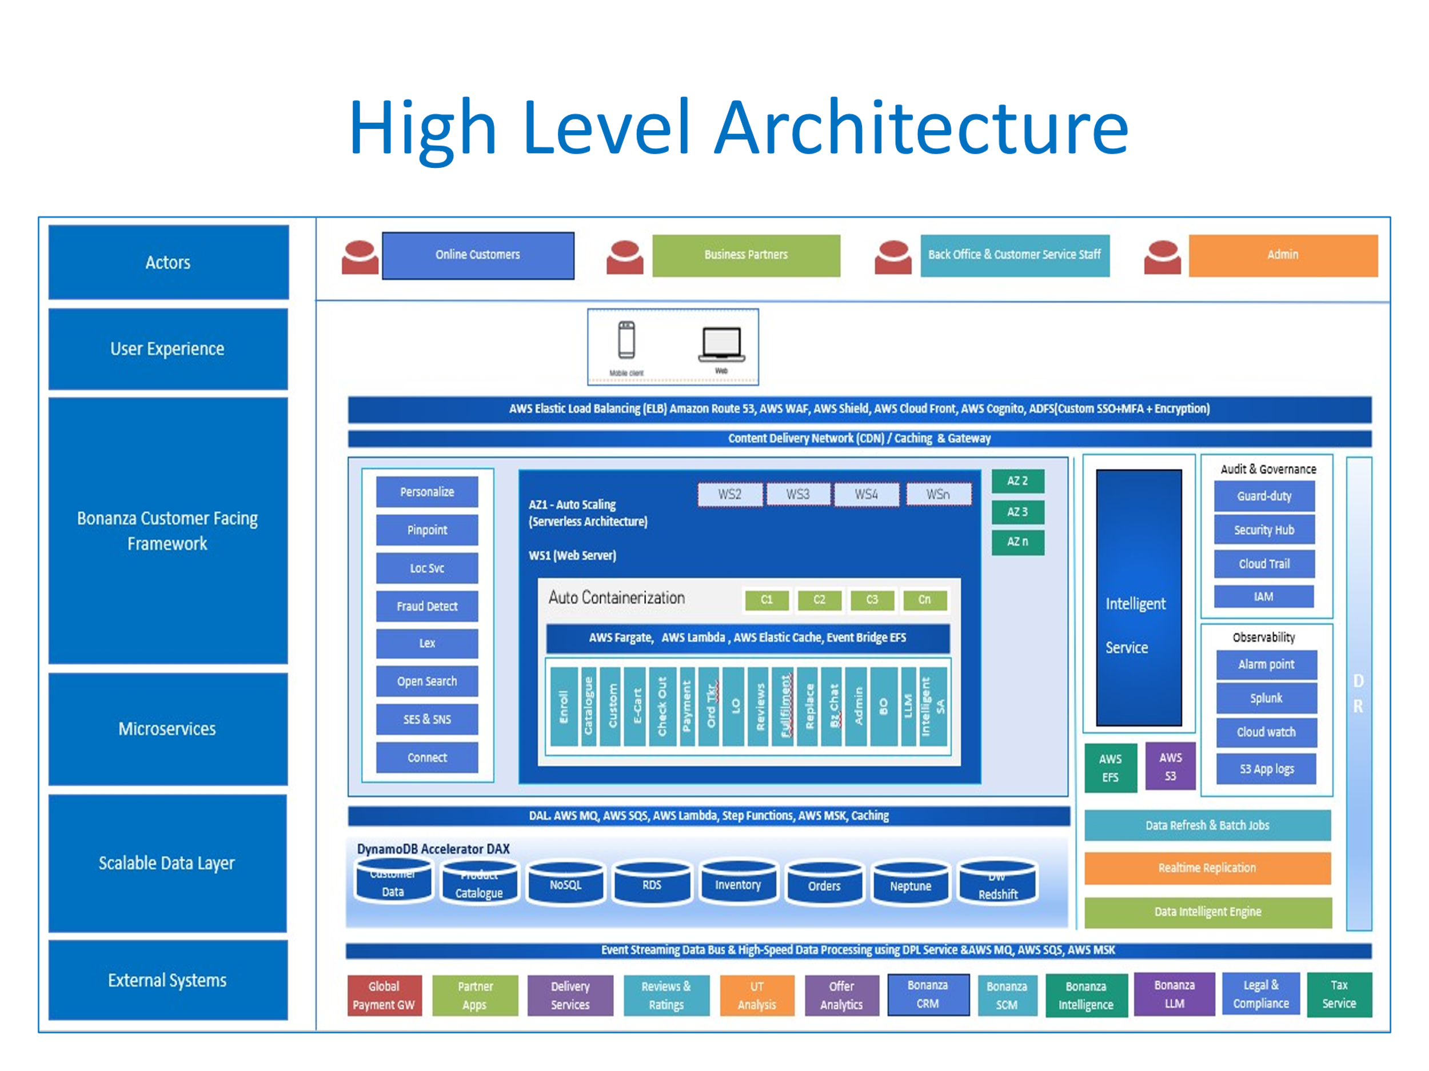

Summary of technical stack:

Architecture Components
- Frontend
- Web Application: React.js
- Mobile Application: React Native
- API Gateway
- AWS API Gateway
- Microservices
- Backend Framework: Node.js, Spring Boot (Java)
- Communication: REST based secure communication
- Databases (Multiple data base and data store are used according to the requirements)
  - Amazon DynamoDB: is A fully managed NoSQL database service that provides fast and predictable performance with seamless scalability. It is ideal for applications that require consistent, single-digit millisecond latency at any scale.
  - Amazon RDS : A managed relational database service that supports several database engines, including MySQL, PostgreSQL, MariaDB, Oracle, and Microsoft SQL Server. It automates time-consuming tasks such as hardware provisioning, database setup, patching, and backups. We are proposing Oracle for this system.
  - Amazon Neptune: A fully managed graph database service that makes it easy to build and run applications that work with highly connected datasets. Used with recommendation engines, and fraud detection.
  - Amazon Redshift: Specifically designed for data warehousing, which allows you to run complex queries against petabytes of structured data
  - Amazon SageMaker: While not a database, it integrates with various AWS databases and services to provide a comprehensive environment for building, training, and deploying machine learning models
  - Amazon S3 (Simple Storage Service): Object storage service that offers industry-leading scalability, data availability, security, and performance. Used for Storing product images, user-generated content, backups, and static assets like HTML, CSS, and JavaScript files. It is also used for data lakes and big data analytics
  - Amazon EFS (Elastic File System): Provides scalable file storage for use with Amazon EC2 instances.
- Caching Layer (Cache happens at multiple levels including the below – not limited to)
- DNS
- In-Memory Cache: Redis
- Search and Analytics
- Search Engine: Elasticsearch
- Analytics: Google Analytics, AWS QuickSight, or Apache Kafka for real-time analytics
- Containerization and Orchestration
- Containers: Docker
- Orchestration: Kubernetes (K8s)
- CI/CD Pipeline
- CI/CD Tools: Jenkins, GitLab CI, or GitHub Actions
- Auto-scaling and Load Balancing
- Auto-scaling: AWS Auto Scaling, Kubernetes Horizontal Pod Autoscaler
- Load Balancer: AWS Elastic Load Balancer (ELB)
- Monitoring and Logging
- Monitoring: Prometheus, Grafana
- Logging: A combination of ELK Stack (Elasticsearch, Kibana), AWS CloudWatch, Splunk, ServiceNow, Alarm point, AWS SNS service.
- Disaster Recovery
- Backup Solutions: AWS Backup
- Multi-region Deployment: Deploy across multiple AWS regions
- Security
- Authentication: OAuth2, JWT, SSO
- Compliance and Encryption: AWS KMS
- Web Application Firewall (WAF): AWS WAF
- DDoS Protection: AWS Shield

Following systems and subsystems are necessary:
- User Authentication System:
  - Secure user authentication
    - Single Sign-On (SSO)
    - Multi-Factor Authentication (MFA)
Single Sign-On (SSO) : Integrate with OAuth 2.0 for secure and seamless user authentication across multiple platforms.
Multi-Factor Authentication (MFA): Implement TOTP (Time-Based One-Time Password) and SMS-based verification to enhance security. AWS services : Amazon Route S3, AWS Shield, AWS WAF, AWS Cloud Front, AWS Cognito, Custom ADFS with OAuth 2.0, Custom SSO & MFA and encryption to be used.
- E-Commerce Core:
  - Product Catalog Management: A combination of databases are used for this application for scalability and improved performance. DynamoDB is used for customer and product catalogue related data. Redis is used for caching.
  - Shopping Cart and Checkout System: Implement microservices architecture to handle shopping cart and checkout processes independently, ensuring high availability and fault tolerance.
  - Order Management System: Use event-driven architecture with Apache Kafka to manage order processing and ensure real-time updates.
  - Role based service
  - AI based notifications, AI generated recommendations, inventory management and purchase from manufacturers
  - Customer Service
- Payment Gateway Integration:
  - Multiple Payment Gateways across the globe with Failover Mechanisms: Integrate with popular payment gateways like Stripe, PayPal, and local banks, ensuring redundancy and failover capabilities.
- PCI DSS Compliance: Implement tokenization and encryption to secure payment data and comply with PCI DSS standards.

- User Interaction:
  - Order Tracking and Notifications: Use push notifications and real-time messaging protocols like WebSocket to keep users informed about their order status.
  - User Reviews and Feedback System: Implement a review moderation system using machine learning algorithms to filter out inappropriate content.
  - Fraud detection and notification : AWS Fraud detection and AWS SNS/SES services are used for fraud detection and notification. A custom AI Service also used for fraud detection and notification.
  - Lightening alerts for new offers
- Admin Dashboard:
  - Analytics and Reporting
  - Role-Based Access Control
- Infrastructure:
  - Serverless Auto-Scaling env on AWS cloud with Pay-as-you-go pricing
  - Elastic load balancing, Elastic Cache & Caching at multiple levels
  - Multiple availability zones and regions
AWS Auto Scaling to automatically adjust resources based on traffic demands. Use Kubernetes for managing containerized applications. Deploy services across multiple availability zones and regions also to ensure high availability. Implement caching at multiple levels (CDN, in-memory cache) for best performance. Strong encryption, regular security audits, and compliance checks required.

  - Real-Time Monitoring Tools
Implement monitoring solutions like Prometheus and Grafana to track system performance and detect anomalies. Application logs to be written to AWS S3. Application logs and AWS logs will be pulled by Splunk. Tickets will be automatically logged in ServiceNow and notified to production support team immediately. AWS SES & SNS services will be used. Continuous monitoring of application performance and health is required.
  - Graceful Degradation Strategies
  - DR Environment in different regions
AWS Service Pricing Summary:
- Amazon Route 53:
- Hosted zone: $0.50 per month per hosted zone.
- DNS queries: $0.40 per million queries.
- Amazon CloudFront:
- Data transfer out: $0.085 per GB (first 10 TB per month).
- HTTP/HTTPS requests: $0.0075 per 10,000 requests.
- Amazon S3:
- Storage: $0.023 per GB (first 50 TB per month).
- PUT, COPY, POST, LIST requests: $0.005 per 1,000 requests.
- Amazon API Gateway:
- $3.50 per million API calls received.
- $0.09 per GB of data transferred out.
- AWS Lambda:
- $0.20 per 1 million requests.
- $0.00001667 per GB-second of compute time.
- Amazon ECS with AWS Fargate:
- vCPU: $0.04048 per vCPU-hour.
- Memory: $0.004445 per GB-hour.
- Amazon DynamoDB:
- Write requests: $1.25 per million write requests.
- Read requests: $0.25 per million read requests.
- Storage: $0.25 per GB.
- Amazon Cognito:
- $0.0055 per MAU (monthly active user) for the first 50,000 MAUs.
- Amazon CloudWatch:
- Metrics: $0.30 per metric per month.
- Logs: $0.50 per GB ingested.

AWS Service | Brief Description | General Pay-as-you-go Pricing (Example Units)
Amazon Route 53 | Highly available and scalable DNS web service. | Per million queries for standard queries, per million queries for latency-based routing, per hosted zone per month.
Amazon CloudFront | Fast content delivery network service that securely delivers data, videos, applications, and APIs to customers globally with low latency and high 1 transfer speeds. | Per GB of data transferred out of CloudFront edge locations, and per HTTP/HTTPS request. Pricing varies by geographic region of the edge location.
AWS WAF (Web Application Firewall) | A web application firewall that helps protect your web applications from common web exploits 2 and bots. | Per Web ACL per month, per million web requests processed, and per rule added (beyond a free tier).
Amazon S3 | Highly available and durable object storage service. | Per GB of storage per month (varying by storage class), per request (GET, PUT, etc.), and per GB of data transfer out of the AWS Region.
Amazon Cognito | Provides authentication, authorization, and user management for web and mobile apps. | Pricing for User Pools is based on monthly active users (MAUs) and optional advanced security features. Pricing for Identity Pools is based on the number of authentications.
Application Load Balancer (ALB) | Automatically distributes incoming application traffic across multiple targets, such as EC2 instances, containers, and IP addresses. 3 | Per Load Balancer-hour and per GB of data processed by the Load Balancer.
Amazon API Gateway | Fully managed service for creating, publishing, maintaining, monitoring, and securing REST, HTTP, and WebSocket APIs at any scale. 4 | Per million API calls received. Pricing can vary based on API type.
AWS Fargate | Serverless compute engine for containers. | Priced based on the vCPU and memory resources used by your tasks from the time they are downloaded until they terminate, rounded down to the nearest second.
Amazon ElastiCache | In-memory data store service compatible with Redis and Memcached. | Per node-hour, varying by node type (size and performance).
Amazon DynamoDB | Fully managed NoSQL database service. | Per GB of data stored per month, per million write request units, and per million read request units. Pricing varies based on the chosen capacity mode (on-demand or provisioned).
AWS Lambda | Serverless compute service to run code without provisioning or managing servers. | Per request (first 1 million requests per month are free for a limited time), and per GB-second of compute time consumed.
DynamoDB Accelerator (DAX) | Fully managed, highly available, in-memory cache for DynamoDB. | Per node-hour, varying by node type (size and performance).
Amazon EventBridge | Serverless event bus that makes it easy to connect applications with data from a variety of sources. | Per million events published (first 1 million events per month are free).
Amazon EFS (Elastic File System) | Simple, scalable, elastic file storage for Linux-based workloads for use with AWS Cloud services and on-premises resources. | Priced based on the amount of data stored in the file system per month (Standard and Infrequent Access tiers). There are also charges for throughput beyond the baseline.
Amazon OpenSearch Service | Fully managed, scalable search and analytics service powered by Elasticsearch and OpenSearch. | Per instance-hour, varying by instance type, storage consumed, and data transfer.
Amazon Personalize | AI/ML-powered real-time personalization and recommendation service. | Priced based on training hours, inference hours, and data storage.
Amazon Pinpoint | AWS service for marketing communications and customer engagement. | Pricing varies based on the channels used (SMS, email, push notifications) and the number of messages sent or users targeted.
Amazon Location Service | Provides location data, maps, geocoding, routing, and places functionalities. | Pricing varies by service component (Maps Tiles, Geocoding, Places, Routing, Tracking) and the number of requests or tracked assets. Has a free tier for initial usage.
Amazon Fraud Detector | Fully managed service that uses machine learning to detect potentially fraudulent online activities in real time. | Priced per prediction, and optionally for data storage and model training. Has a free tier for initial usage.
Amazon Lex | Service for building conversational interfaces into any application using voice and text. | Priced per text or voice request processed. Has a free tier for initial usage.
Amazon SQS (Simple Queue Service) | Fully managed message queuing service that enables you to decouple and scale microservices, distributed systems, and 5 serverless applications. | Per million requests (first 1 million requests per month are free indefinitely). FIFO queues have a slightly higher price per request.
Amazon MSK (Managed Streaming for Apache Kafka) | Fully managed and highly available service for Apache Kafka. | Per broker-hour, storage consumed per broker, and data transfer in and out of the brokers. Pricing varies by broker instance type and AWS Region.

Above pricing details are given for reference purposes only. AWS pricing varies according to volume, speed, region etc. We propose to develop prototype first and do the needful automation testing, load/stress testing and other performance testing to capture the details on expected volume of data, data type and frequency processed. Based on this, we can identify the initial AWS infrastructure cost. Development of application development and other technical support need to be calculated separately. We will finalize these areas after further discussions.
- Graceful Degradation Strategies: Design the system to degrade gracefully under heavy load, prioritizing critical functionalities and maintaining user experience.
Information Exchange
- Frequency: Continuous data exchange for real-time updates.
- Speed: High-speed transactions to meet the API response time of < 200ms.
- Volume: Large volumes of data due to high user activity and transaction rates.
Detailed breakdown of data types, exchange frequency, speed and volumes:
Description | Data Type | Frequency | Speed | Volume
User Authentication and Session Data | JWTs, OAuth Tokens, MFA Codes, User Profiles (PII) | High  1M+ daily logging (peaking at 250 K concurrent) | <100ms latency for SSO/MFA flows | ~50KB per session (token + encrypted user data)
Product Catalogue | Product meta data, inventory counts, images | Extreme  10K+ reads/sec (peaks), writes ~10/sec (admin updates) | Cache hits (Redis)  <5ms, DB reads (MongoDB) <20ms | ~1 TB total (images dominate), Cache holds ~10 GB hot items
Shopping Cart | Item IDs, quantities, user session IDs | Spiky  50K+ updates/sec (add/remove items during peaks) | Redis-backed cart < 10ms write latency | ~100MB/sec transient data (ephemeral storage)
Checkout & Payments | Order details, payment tokens (PCI-compliant), fraud scores | Critical  10K TPS sustained during peaks | Payment processing: 200-500ms (gateway latency) | ~1GB/min order data (Cassandra writes)
Order Fulfillment | Shipping addresses  Tracking IDs  Status updates | Bursty  5K+ updates/sec (status changes) | DB Writes <50ms (Cassandra optimized) | ~500MB/hours (logs + DB entries)
Notifications | Emails (order confirmations), SMS (OTPs), push notifications | Async  50K+ notifications/hour (peaks) | Queue processing <1 sec (Kafka/SQS) | ~10MB/min (text-heavy)
Analytics & Monitoring | Clickstream data, logs, metrics (CPU, latency) | Continuous  100K+ events/sec (Prometheus) | Near real-time (1-5 sec delay for dashboards) | ~10GB/day (compressed logs)
Batch Processing | Batch processing with external systems partner apps | Continuous streaming data over data bus, MQ, AWS Streaming service | Batch processing every 1 hour | ~10GB per hour
Data Flow Summary:
Component | Data Type | Frequency | Speed Requirement | Peak  Volume
User Authentication and Session Data | Tokens, PII | 1M+/daily | <100ms | ~50KB per day
Product Catalogue | JSON, images | 10K+ reads/sec | <20ms (DB) | ~1 TB Storage
Shopping Cart | Session Data | 50K+ updates/sec | < 10ms | ~100MB/sec
Payments | PCI tokens | 10K TPS | <500 ms | ~1GB/min
Order Fulfillment | Shipping addresses  Tracking IDs  Status updates | Bursty  5K+ updates/sec (status changes) | DB Writes <50ms (Cassandra optimized) | ~500MB/hours (logs + DB entries)
Notifications | Emails, SMS | 50K/hour | <1 sec async | ~10MB/min
Analytics & Monitoring | logs, metrics | 100K+ events/sec | <1 sec async | ~10GB/min
Batch Processing | Batch processing with external systems partner apps | Continuous streaming data over data bus, MQ, AWS Streaming service | Batch processing every 1 hour | ~10GB per hour
Potential Failure Points
- User Authentication Failures: Issues with SSO or MFA.
- Payment Gateway Failures: Downtime or transaction failures.
- System Overload: Inadequate scaling during peak loads.
- Data Breaches: Non-compliance with security standards.
Mitigation Actions
- Redundancy: Implement failover mechanisms for critical systems.
- Load Testing: Regular stress testing to ensure scalability.
- Security Measures: Adherence to PCI DSS, GDPR, and CCPA.
- Monitoring: Real-time monitoring and alert systems.
Contingency Plans
- Backup Systems: Maintain backup servers and databases.
- Disaster Recovery: Develop a comprehensive disaster recovery plan.
- Graceful Degradation: Ensure the system can degrade gracefully under load.
Load Management
- Average Load: Optimize cost-efficiency while maintaining performance.
- Peak Load: Implement auto-scaling and load balancing to handle spikes.

Conclusion
The e-commerce application designed for Black Friday sales on AWS Platform will be robust, scalable, and secure to handle the high demands of such an event. By addressing the outlined requirements and considerations, we can ensure the platform's success and reliability. This model can be replicated overseas to achieve similar success in different markets as well. Kindly look at the business report and reply to us. We are looking forward for an opportunity for detailed presentation during which time we will be able to give you approximate cost as per the pay-as-you-go pricing given by Amazon. We will be using AWS Pricing Calculator: https://calculator.aws/ to calculate cost incurred to avail AWS Services. Looking for further discussions and actions on this.

Regards
Prakash E
19th April 2025

